EQUATION OF A LINE
Pearson Edexcel - Thursday 7 June 2018 - Paper 2 (Calculator) Foundation Tier

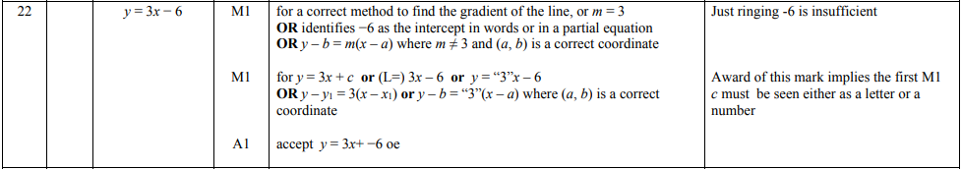

Pearson Edexcel – Specimen 1 - Paper 3 (Calculator) Foundation Tier

OCR Thursday 07 November 2019- Morning (Non-Calculator) Foundation Tier
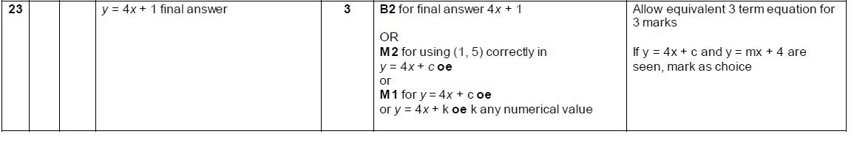

OCR Wednesday 8 November 2017– Morning (Calculator) Foundation Tier

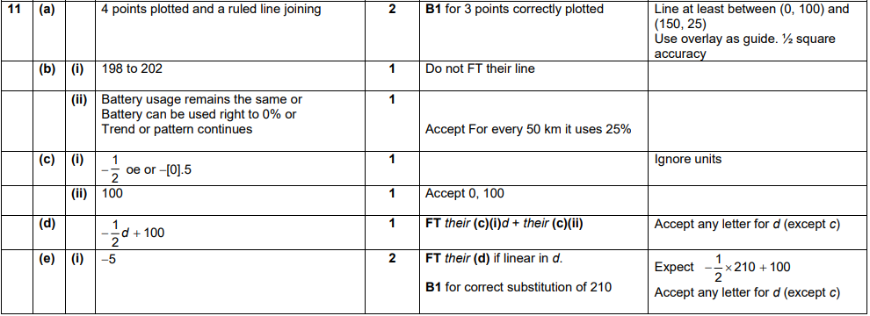

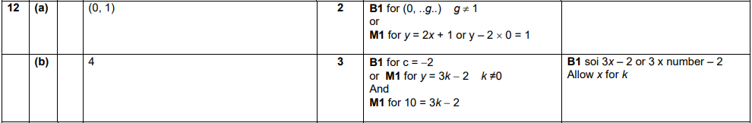
AQA Tuesday 19 May 2020 – Morning (Non-Calculator) Foundation Tier

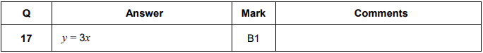

AQA Monday 8 June 2020 – Morning (Calculator) Foundation Tier

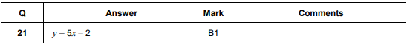
AQA Thursday 6 June 2019 – Morning (Calculator) Foundation Tier

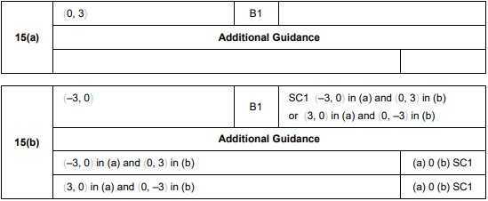
AQA Thursday 11 June 2019 – Morning (Calculator) Foundation Tier

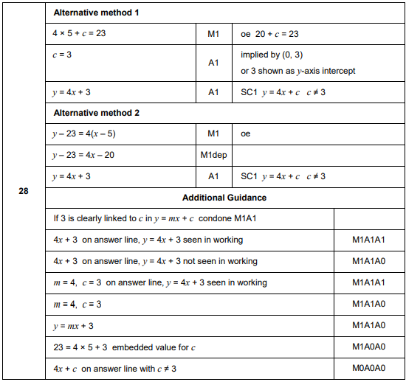
AQA Thursday 24 May 2018 – Morning (Non-Calculator) Foundation Tier

